THE BOOKLET
London Zoo
1. 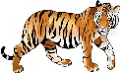, 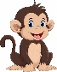, 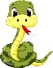 and 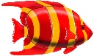 in the centre of London! These animals all live in the London Zoo, one of the largest in the world. It is the home for big amount of different kinds of animals. The zoo also has many exotic animals and birds. Get a map to make sure you see everything.
2. First, visit the Animal Island. There you can see the African 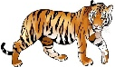, the Indian , the Himalaya , the Asian 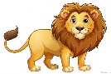and even an Australian 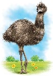. There you can also see colorful fish in large aquariums. Don’t miss the Night World exhibition too! This is a great chance for you to see the night animals.
3. All the young visitors must see the Children’s Zoo. Children can see the heroes of cartoons: 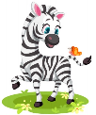, 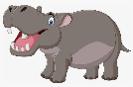 , 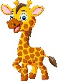 and many other animals. There are also cafés and picnic areas. Kids can visit playgrounds. You will not forget the day in the Moscow Zoo!

Match the titles with the passages

A) For young visitors B) About Moscow Zoo C) Animals
1 passage | 2 passage | 3 passage

